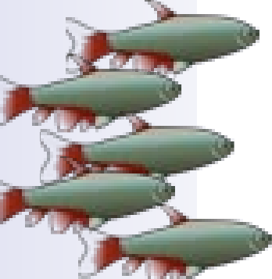 



**N ORWALK AQUARIUM SOCIETY WHERE FRIENDS AND FISH MEET**



55th Annual Tropical Fish &

Aquarium Equipment Auction

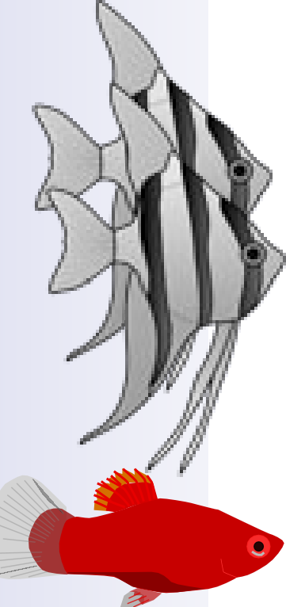One of the Northeast's Largest Auctions of Beautiful Tropical Fish, New & Good Used Aquarium Equipment!

NEW LOCATION

Where Westport VFW

465 Riverside AVE, Westport CT

*please park in the back and use* *back door*

When Sunday, October 2, 2022

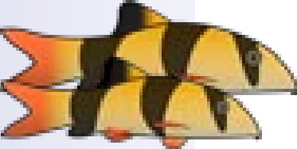Registration/Viewing: 9:00-11:00 a.m. Auction Starts at 11:30 p.m.

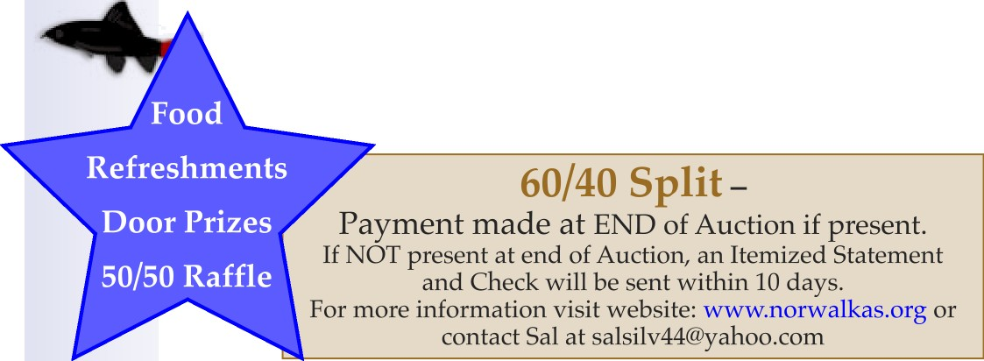

*Auction is open to the* Public

*Free Bidder Cards. Lot Bumps $2*

download auction registration form at [WWW.norwaIkas.org](http://WWW.norwaIkas.org)